OS & SP
Name : S LOHITHA Roll No : 2520030109
Practical – 06
Server.c
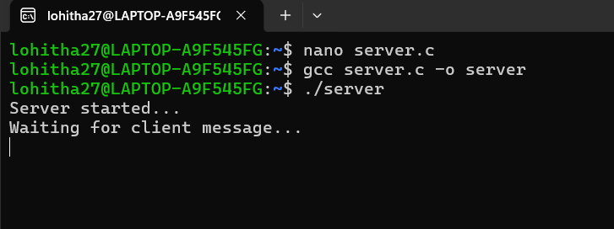
Client.c
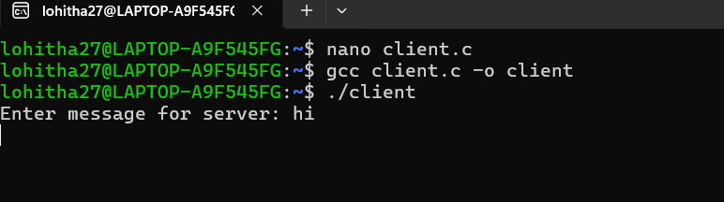

Signals.c

